CCMCS402: COMPUTER SKILLS

Date: 26th Nov 2025
Period: 08:00AM – 10:00AM

SCHOOL COMPREHENSIVE ASSESSMENT
SECTOR: ALL
RTQF LEVEL: 4
TRADES: NIT, FAD, WOT, and BDC
55

MARKS:
DURATION: 2 HOURS
INSTRUCTIONS TO CANDIDATES:
- This Exam paper is composed of TWO (2) Sections (A, and B). Follow the instructions given below, and answer the indicated questions for a total of 55marks
Section A: Attempt all questions of THREE (3) parts. (35 Marks)
Section B: Attempt only 2 questions of your choice (20 Marks)
2. Use only blue pen or black pen.

SECTION A: 35 Marks
PART A: Choose the correct answer (Multiple Choice):
- Which of the following best defines an Operating System?
A. A program used only for gaming
B. A system software that manages computer hardware and software
C. A device used to store data
D. A special type of printer
- An operating system acts as a bridge between the user and the ______.
A. Application
B. Network
C. Internet
D. Hardware
- Which one is a feature of an operating system?
A. Car acceleration
B. Weather prediction
C. Multi-tasking
D. Mobile charging
- A computer freezes because too many programs are running. Which OS function is MOST responsible?
A. Memory management
B. Security management
C. File management
D. Device management
- Memory management in an OS mainly deals with:
A. Storing movies
B. Handling and allocating RAM
C. Printing documents
D. Repairing hardware
- Which OS function is MOST important for preventing unauthorized access?
A. Device management
B. Security management
C. File management
D. Memory management
- What is the difference between a file and a folder in a computer's file system?
- A file is a container for storing data, while a folder is a collection of files.
- A folder is a container for storing data, while a file is a collection of folders.
- A file and a folder are the same thing; they both store data.
- A file is a physical object, while a folder is a digital object.
- Which of the following is NOT an example of an operating system?
  - Windows 10
  - Mac OS
  - Linux
  - Google - Chrome
- The core part of the OS that communicates with hardware is called:
A. File system
B. Browser
C. Kernel
D. Desktop
- A GUI mainly uses on:
A. Commands only
B. Icons and windows
C. Only text files
D. Only voice instructions
PART B: Answer by True / False
- GUI requires typing commands to run programs.
- Network OS is used to control and manage computers that are connected together.
- The OS handles memory allocation to different applications
- An embedded OS is used in general-purpose computers like laptops.
- Time-sharing OS allows multiple users to share CPU time.
- A soft real-time OS guarantees strict timing deadlines.
- File management includes renaming, moving, and deleting files.
- The kernel is responsible for connecting the computer to the internet.
- The operating system helps the user to interact with the computer.
- A file extension can help you determine the format and type of a file.
PART C: Match the OS Characteristic to Its Description
1.
Column A (OS Characteristics & Shortcuts) | Column B (Descriptions) | Answers
A. Multiuser | 1. Allows only one user to work on the computer at a time. | A. _____
B. Single-user OS | 2. Allows two or more users to use system resources at the same time. | B. _____
C. Multitasking OS | 3. Enables one user to run multiple programs simultaneously. | C. _____
D. Multiprogramming OS | 4. Loads several programs in memory and lets CPU switch between them. | D. _____
E. Shortcut: F2 | 5. Uses two or more processors to perform tasks at the same time. | E. _____
F. Real-Time OS (RTOS) | 6. Provides instant responses and meets strict timing deadlines. | F. _____
G. Distributed OS | 7. Controls multiple computers and makes them act as one system. | G. _____
H. Time-Sharing OS | 8. Shares CPU time among many users using time slices. | H. _____
I. Multiprocessing OS | 9. Used to rename a selected file or folder. | I. _____
J. Shortcut: Delete Key | 10. Used to delete a selected file or folder. | J. _____

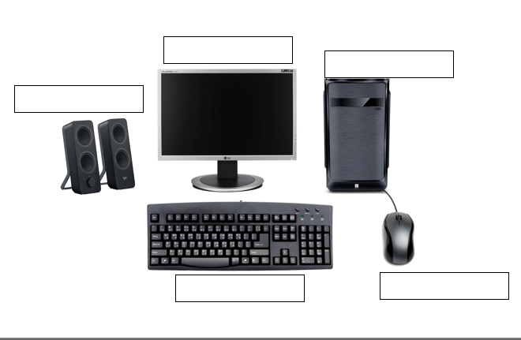
2. Write the names of each computer part (5 marks)

SECTION B: Choose only Two (2) Questions (20 marks)
1. You are a student at PADRI VJEKO CENTRE TSS studying Fashion Design (FAD). You need to organize your project sketches for your new clothing line.
a) Create three separate files named Sketch1.docx, Sketch2.docx, and Sketch3.docx in a folder called Fashion_Project. Write the steps you would follow to create these files. (3 marks)
b) Copy Sketch1.docx and paste it into a folder named Backup_Sketches. Describe the steps you will take to do this. (2 marks)
c) Open Sketch2.docx and add a new description about the type of fabric used. Explain how you will save the changes. (3 marks)
d) Select Sketch1.docx and Sketch3.docx together to move them into another folder called Final_Designs. Show the steps for selecting adjacent and non-adjacent files. (2 marks)
2. You are tasked with managing drawings and reports for a Building and Construction project (BDC).
a) Create three files named FloorPlan.xlsx, MaterialList.xlsx, and Budget.xlsx in a folder called BDC_Project. List the steps you will follow to create these files. (3 marks)
b) Copy MaterialList.xlsx and paste it into a folder called BDC_Backup. Explain the steps you will take to do this. (2 marks)
c) Open Budget.xlsx and update the estimated cost of cement. Write the steps and explain how you will save the changes. (3 marks)
d) Select FloorPlan.xlsx and Budget.xlsx (non-adjacent files) to move them into a folder called BDC_Final. Show the steps for selecting non-adjacent files. (2 marks)
3. You are organizing your school projects from all four departments (FAD, BDC, WOT, NIT) into a master folder.
a) Create a file for each department inside a folder called All_Projects: FAD_Project.docx, BDC_Project.docx, WOT_Project.docx, NIT_Project.docx. Show the steps you will follow. (3 marks)
b) Copy the All_Projects folder to a USB drive named Backup_2025. Describe the steps you will take. (2 marks)
c) Open FAD_Project.docx and add the latest project update. Explain the steps to edit and save the file. (3 marks)
d) Select BDC_Project.docx and WOT_Project.docx to move them into a new folder called Technical_Projects. Show the steps for selecting non-adjacent files. (2 marks)
GIVE IT YOUR BEST!

